Atomica Corp. EOI-
Operation of PROBE08 (Accretech UF200R) Version: 4.0



Title: Operation of GUI

Document type:

Document ID: EOI
Author:
Owner:

Approver(s):
Approval date:
Effective date:
Next periodic review date:

Atomica Corp. EOI-249
Operation of PROBE08 (Accretech UF200R) Version: 4.0

Purpose
The purpose of this document is to provide instructions for using GUI for recipe creation, wafer map generation, and setting up for the Accretech and Electroglas electrical probers. Furthermore, there will be a section on NanoZ for the Nautilus project specifically.

Scope

  - This procedure is designed for any personnel designing recipes or trying to do electrical probing on new programs.

References

Deﬁnitions
Table 4: Definitions of terms, acronyms, and abbreviations

Term | Deﬁnition

Responsibilities
  - It is the responsibility of persons operating PROBE08 to read this document.
  - It is the responsibility of the Metrology Engineer to maintain this document.
Atomica Corp. EOI-249
Operation of PROBE08 (Accretech UF200R) Version: 4.0

General Tour of Main GUI

  - All internal memory of settings and wafer maps and programs are loaded in what is called an “ATA folder” (folder ending with “ata”). The default working directory should have some already, you can pick from the top dropdown or load a specific folder using the button if not found. After loading, you will see what was found (and auto loads into other tabs). The GUI allows to edit and save to ATA, user should never have to directly edit a csv inside the folder.

Figure 6a: Loaded MADDYATA folder
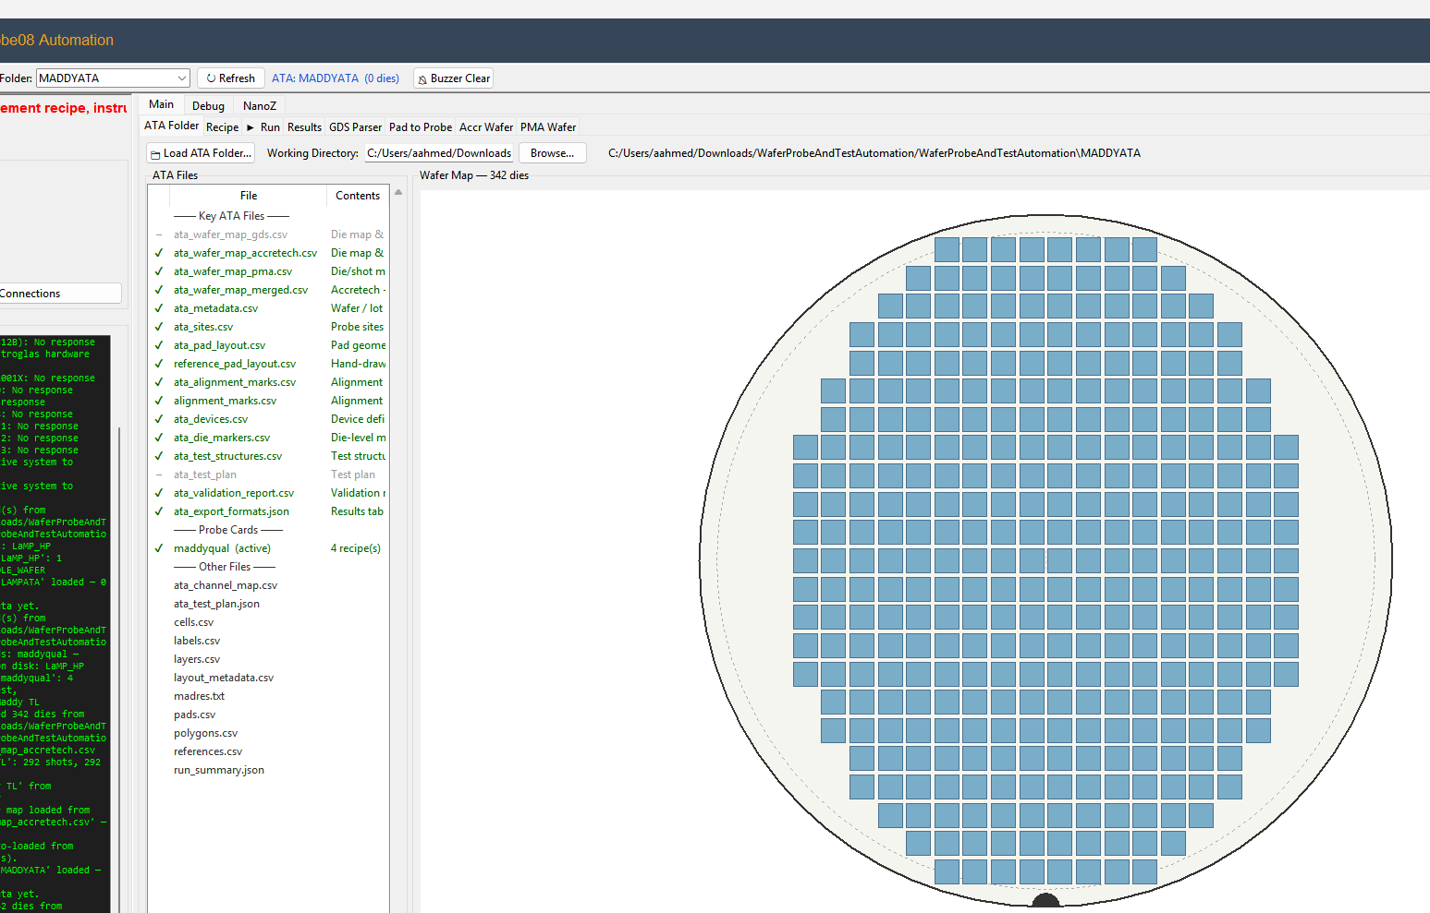

  - Top Bar: Since this GUI works with both Accretech and Electroglas, the top right has a toggle to select the corresponding machine. Orange means selected. The tabs (and recipes and maps) will update accordingly, you should not have to change ATA folder if its the same program.
Figure 6b: Accretech/Electroglass toggle
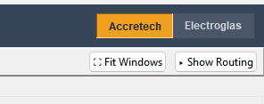
    - Click Fit Windows if the information gets cut off (modifies display only). Click show routing if you would like to see the live switch connections, and it will appear on the bottom. This is the same as the routing tab under the Debug section, but you should not have to touch anything there during normal operation.
Figure 6c: Toggle Switch Routing tab
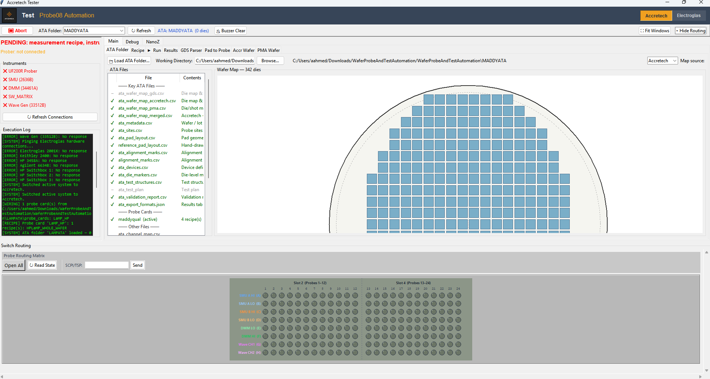
    - Finally, the red Abort button will send a stop command to the prober, in case you want to stop a run or something hazardous could occur. Press buzzer clear if the buzzer/alarm is going off next to the prober (or you could just click on the prober display as well). Click refresh if the ATA folder tab is not synced correctly.
Figure 6c: Misc buttons

  - Under the Probe Card tab, you can register new probe cards if they are not already in the ATA folder (or edit existing ones). To do so, Name the card (preferred is to match exactly what is on the white label on the card). Then add pins and number them based on the actual wiring pinout. Contact probe card owner if you don’t know. The pad entry is just a label for reference, editing pads or pad layout will not affect operation. (Net is also just another label, both can be omitted). The actual pad layout and registration is done on the prober itself. Make sure to press save all when done.
Figure 6c: Example Probe Card Wiring
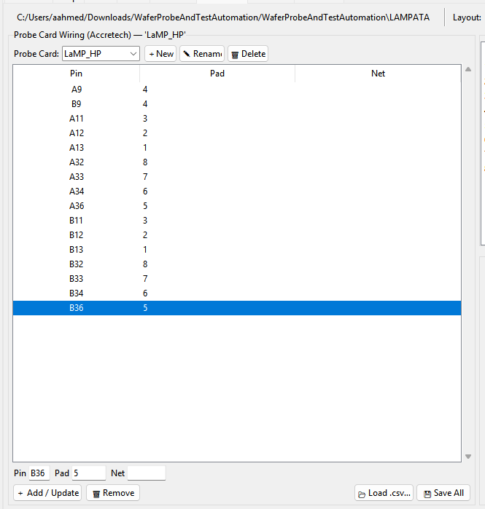
  - (For Accretech), the Accr Wafer tab allows you to save the wafer map after training it on the probe08. You should only have to use this tab after training a new wafer type on the prober (see on how to register a new device data file on Accretech, including pad registration and alignment marks). To use it, make sure the wafer is loaded and prober is in the “probing” state. Click extract wafer map, and it will iterate through the dies to build a map. After done, just click save to ATA folder, and press unload in the run tab.
Figure 6c: Button to extract map from Accretech
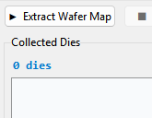
  - Recipe tab: This will be tab for recipe creation, or more specifically, the exact electrical test that will be done on the pads of the wafer through the probe card pins. The recipe is setup to show a step by step measurement list that is considered one iteration of a shot/die. For example, when the prober lands on a shot/die and pins touchdown, the recipe will give the exact switch connections, instrument settings, delays, and thresholds that will be executed before the chuck is raised again and the prober moves to the next location.
Figure 6c: Recipe Tab (showing Accretech gage recipe)
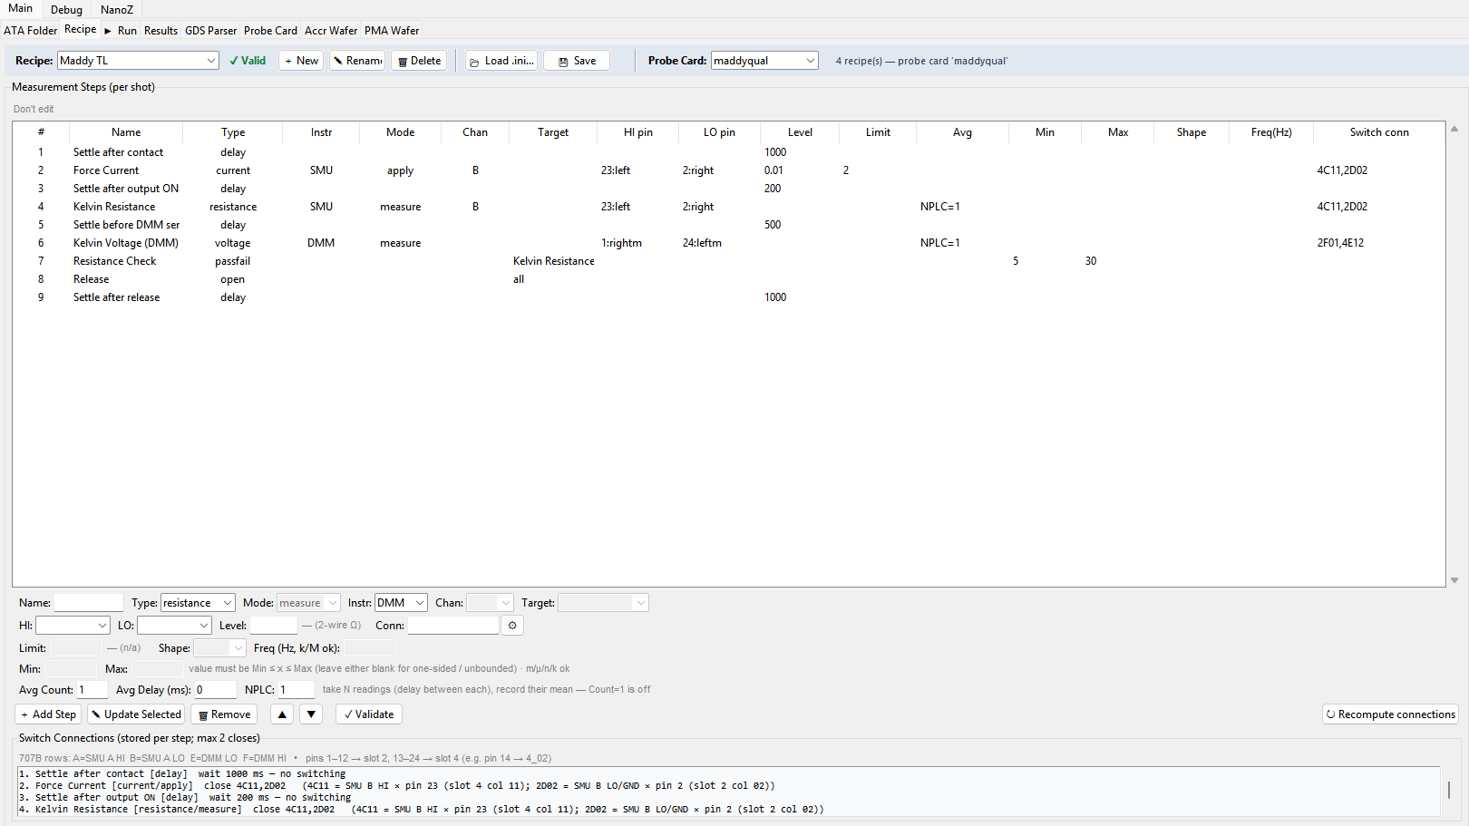
    - Top bar: The recipe dropdown allows to switch between recipes. It will show only the ones in the current ATA folder (and changing folder automatically switches). The probe card dropdown also allows to select from the probe cards (created in the aforementioned tab). IMPORTANT: Each ATA folder can have multiple probe cards. Each probe card can have multiple recipes. Each recipe needs to be under a specific probe card and needs to match, or else the measurements and pinouts won’t make sense.
Figure 6c: Recipe Top Bar
To create a new recipe, click new; clicking delete will delete current recipe. You should not need load .ini, it is there if you need to load something outside of the ATA folder.
    - To create a recipe, you have to add steps and configure them. You can select the instrument, the type of measurement (input or output or delay or pass fail check), the channel, limits, ranges, etc. Important to remember is that each step can affect at most 2 pins and close two switch connections. For example, as shown below, to apply current between two pins, you can name the step whatever you like, select current and apply (not measure), select an open channel for the source meter, select the two pins HI and LO, write the amount of current (10m means 10 milliamps, without a letter modifier would mean 10 amps, etc.), the limit (cap at 2 volts, it would be amps if you applied voltage). You could also manually put the switch connections, but the GUI should automatically figure it out once step is added (or click button next to Conn).
Figure 6c: Measurement Step Configurations
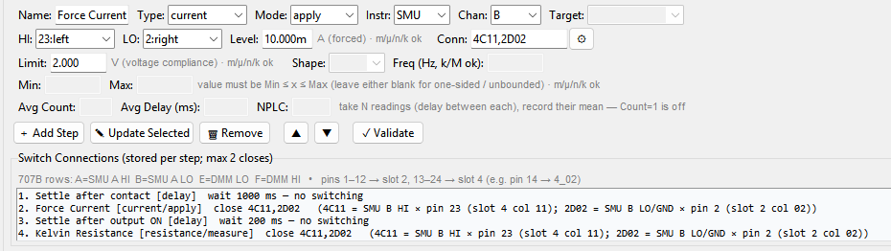

    - Measurement types:
Figure 6c: Recipe Dropdowns
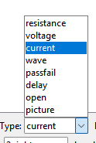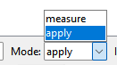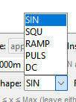
As shown, there are many options. The resistance, voltage, current, and wave are physical input or output to the pins using the instruments available. Select measure or apply to change from read or supply power. Something to note is that even when measure is selected, you can apply a biasing voltage or current simultaneously, so it is important to keep track of measure steps as well and open the connections after done.
The passfail type should be a step at the end after taking a measurement. You can apply this step to one of the previous measure steps. Put a min and/or max value to set a threshold for whether that die should be treated as a pass or fail die (and the wafer map will update with green or red).
The open type, similarly, should be applied to a previous measurement step that will open the connections that are closed. It can also be set up to open all connections. You should open all at the end for the sake of ensuring short prevention and keeping things consistent.
The delay type will apply a set millisecond wait period before moving onto the next step. This is important to allow for settling time, rise times, touchdown, pin vibrations, instrument readings, etc. Exact time varies depending on instrument, but around 200-500ms is a safe amount of time for most.
For the measure steps, you can also setup an averaging. This means that step will be repeated a set amount of times, and the final reading will be an average of all the measurements. To do this, just put the Avg count for the number of repetitions, and the avg delay between each measurement, and/or NPLC, which is a SMU setting that sets the number of power line cyces per reading. You will still only receive one reading in the results tab after an averaging step.
Figure 6c: Configurations and Connections

Add step to create a new one, update selected to change the highlighted step, and remove to delete highlighted step. Click the arrow keys to move the highlighted step up and down the order. (You can duplicate a step by highlighting it, then clicking add step). Press recompute connections to auto create the switch connections. You can see some more info in the log at the bottom.
    - Finally, once a recipe is done, press validate and the GUI will assess whether the ordering makes sense, whether switch connections short or don’t match, and whether there are enough open steps. You should only use a recipe that has the valid checkmark, but the GUI won’t lock you from it.
Figure 6c: Validation
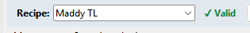
    - Remember to press save anytime a recipe is edited, it will save in the ATA folder under the probe card listed.
  - Run Tab: This is the main tab that will communicate with the prober itself.
Figure 6c: Run Tab
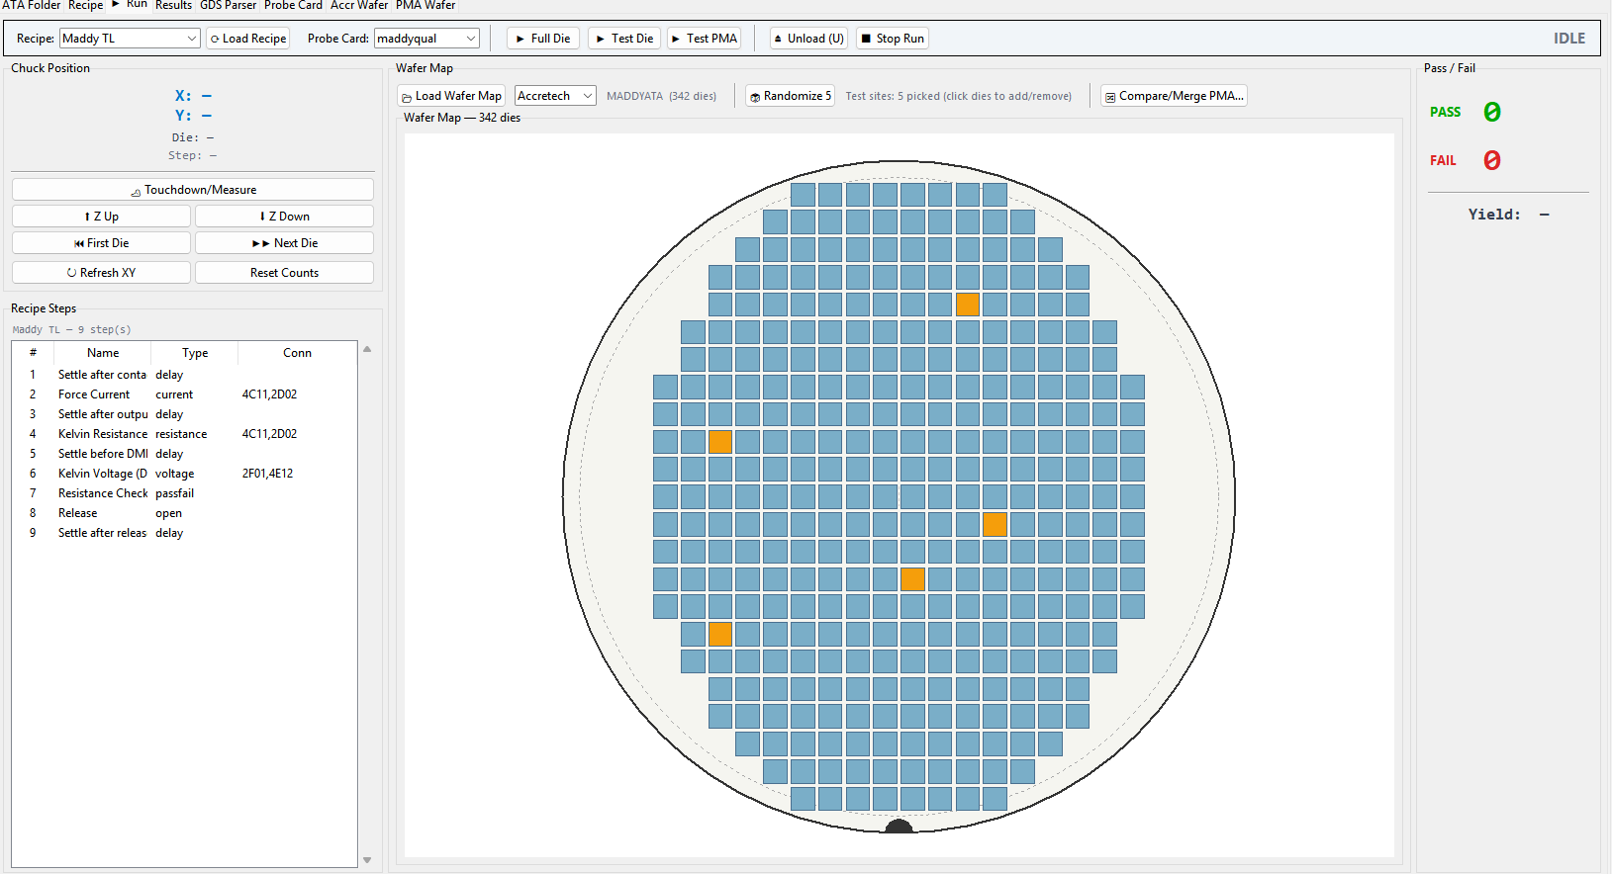
    - Here, you can must load the recipe first by pressing the load recipe button. Choose from the dropdown or change the ATA folder or probe card under recipe tab if you can’t find it.
    - Full Die will test every die on the map (for Accretech it will match every die on the display). Test die will test selected dies. You can randomly test by pressing randomize 5 to select and then pressing test die, or you can manually click on the squares to choose which ones to test.
    - Stop Run can be used similar to the abort button, it will send a stop command to the prober. Unload should be used after finished running, it will send the wafer back to the front door or cassette.
    - The other buttons are manual movements, but should not be used during normal operation. Touchdown measure will execute one iteration of the recipe steps. Z up moves chuck up (meaning NOT SAFE TO MOVE). Z down moves chuck down, meaning chuck can now move since pins are not touching the wafer. First die will send the chuck to the first die (usually top left) of the wafer. Next die moves to the next die, and will be highlighted on the squares of both this GUI and the Accretech. XY gives the current position of the chuck.
    - Based on the pass fail requirements of the recipe, the squares will be highlighted green or red after each iteration. If no pass fail is set up, all squares will be green. You can reset counts to clear the pass fail counter if needed, and then press first die, then try testing again. Once done with a test, you can move onto the Results tab to save.
  - Results tab will display measurements and allow to save in multiple different ways.
Figure 6c: Results Tab
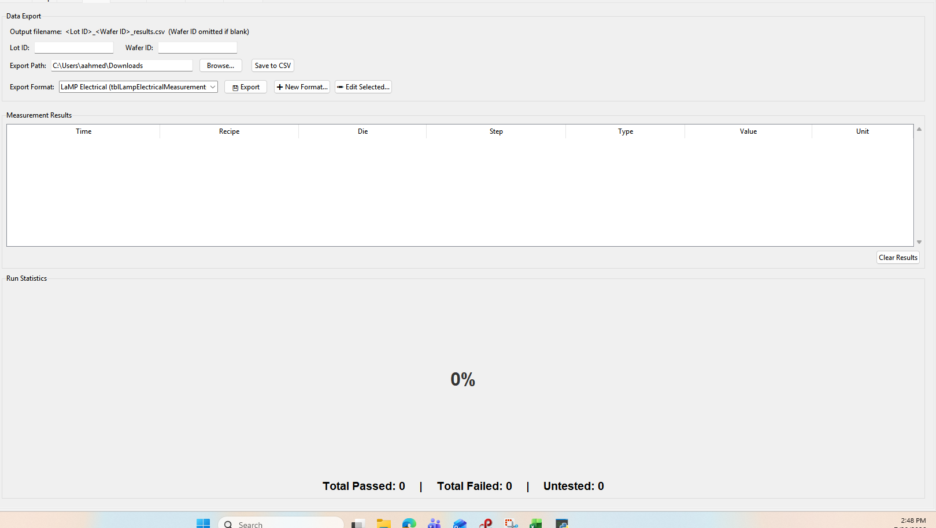
    - Make sure to put lot id and/or wafer id before saving. Check that the export file path is the one you expect the output to end up in, or press browse to change it.
    - Save to CSV will do the barebones save, but you have options to fit different formats. Lamp has a sql setup and the format for that is already loaded, and Maddy (including gage) is a csv that is also loaded. If a new type needs to be added, press new format. In the popup window, name and decide on type of output file, order the results in the preferred format, decide what the column labeling will be, whether to modify the values by a scaling factor, or just replace them with a constant, etc. Save format at the end, and you can pick this new one from the dropdown.
Figure 6c: New Format
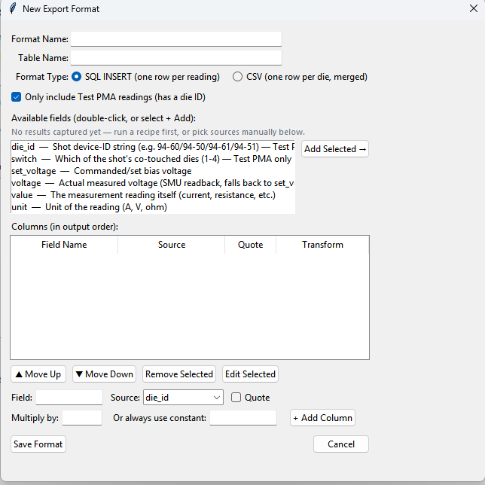
    - The results will show a timestamp, the recipe and the step it came from, the die id of that specific measurement on the wafer map, and of course, the value and the units. Remember to clear results if you want to run another test, or if the test was aborted, or else the next values will just be appended at the end.
  - PMA wafer
  - GDS Parser tab: This is a tab that is mostly for reference on the wafer maps. It can take a gds file and extract information about the wafer map, alignment structures, pitch, etc. You can click open gds file and choose one, then wait for it to parse, then click generate ATA files to merge with an existing folder (or create a new ATA folder if needed). There are many sub tabs you can explore, but in general they should not affect the machines operation, but give you an idea of the layout for the project.
    - In run tab, use Accretech or Electroglas wafer map for operation, not GDS (from the dropdown).

    - d

Debug Section
  - Instruments tab shows the relevant devices that are connected such as DMM, SMU, and Wave generator (different for Accr vs EG). You can use that tab to send commands for testing such as set voltage, read resistance, set current limits, etc. You can also send raw SCPI commands to each instrument if the button that you want is not listed (use the manual to figure out the GPIB command).
    - PROBE08 Accretech UF200R Fully Automatic Prober
      - KEYSIGHT 34461A Digital Multimeter
      - KEITHLEY 2636B Source Meter
      - KEYSIGHT 33500B Waveform Generator
    - PROBE02 Electroglas 2001CX
      - KEYSIGHT 2400 Source Meter
      - KEYSIGHT 3458A Digital Multimeter
      - AGILENT 6634B Power Supply
  - Switch tab shows the switch matrix or relay that is used for that probe. For Accretech it is the KEITHLEY 707B Switching Matrix, and for Electroglas it is the . You should not need to press anything during operation.
    - For Accretech, probe routing shows the current switch setup and you can click on crosspoints to close and open. (MAKE SURE TO OPEN ALL BEFORE CLOSING). Read state to make sure the live view is accurate, or send SCPI commands to the Keithley 707B if needed. Under switch settings, you can edit the setup if for example, there have been more switch cards that were added. Click Add slot to add a card, or highlight existing to update. You can input the number of rows and select the rows that you want active, input the number of columns for that card, and make sure to label which physical slot it is in on the 707B. Underneath, you can check how the instruments are physically wired to the switch matrix, make sure to edit this if the wiring was changed. Label each row with the correct instrument, channel (if applicable), HI vs LO pins, etc. Click save settings to save to ATA.
    - For Electroglas, there are multiple relays
  - Prober Debug tab has some of the basic commands for the respective machines (matching the GPIB command manual given). There is also the terminal if you want to send raw GPIB commands. For Accretech, it will not accept commands to move chuck if not in probing state (will just throw error), but you can get current state info for the most part. Remember, zup makes wafer contact probe card, z down makes it safe to move. You can move the chuck with relative distance measurements, but its not recommended since Accretech uses reference dies to move. There is also a list of STB codes as reference to decode some errors that it may throw. For Electroglas, you can set a lot of the configurations for the prober through commands as well.

NanoZ section

Setup
    - (Figure 8a).

Figure 8a:
- Training New Wafer on Accretech
  - create new device file
    - Device Parameter Change
    - Device List reference
    - Click on Existing
    - rename
    - create new device, dont copy
    - load device file
  - Wafer Registration
    - make sure correct probe card
    - load wafer, make sure front access, manual alignment
    - align device edges (note that all may not appear)
    - align street (right and left corner)
    - put unique points
    - click rotate end
    - put reference dies
    - smt
  - Pad Registration
    - operating the squares
    - …
  - Probe Pin alignment
    - can check pads again by
    - align circles to the pins

  - Die map
    - from where to where?
  - Save and use on GUI
    - remember to extract Accr wafer map

Setup Tab
[Insert screenshot here]
Figure: Setup tab overview
The Setup tab is where the physical bench is described to the software: which prober is attached, which instruments exist on that bench, and how they are addressed over GPIB/VISA. Everything downstream (Recipe tab dropdowns, Switch Routing, Debug tabs) reads its instrument list from what is configured here, so a bench must be set up correctly here before recipes can reference its instruments.
This information is machine-specific and lives in the GUI System folder (see Working Directory below), not inside any individual ATA folder - a station's own instrument addresses do not change when a different program's ATA folder is loaded.

Bench / Instrument Profiles
[Insert screenshot here]
Figure: Add Instrument dialog
Each physical prober (e.g. probe08, probe08old, probe02) has its own instrument profile: a named set of instrument slots (SMU, DMM, wave generator, switch matrix, etc.) with the GPIB/VISA address configured for each. Two slots are mandatory on every profile - the prober itself and the switch matrix - since a bench cannot usefully exist without them. Every other instrument slot is optional and can be added or removed freely: a bench can have three DMMs and no wave generator, a single SMU, two SMUs, or any other combination the physical setup actually has.
• Add Instrument: opens a single dialog to choose the instrument type (SMU, DMM, wave generator, power supply, etc.), a specific driver/model if more than one is supported for that type, and its GPIB/VISA address. Confirming adds it to the currently selected bench's profile.
• Remove Instrument: removes a non-mandatory instrument slot from the bench. The prober and switch matrix slots cannot be removed - a bench without either one is not a usable bench.
• Rename: renames a prober/bench profile (e.g. renaming probe08new to probe08 after a hardware swap). Renaming a bench automatically retags every recipe and switch-topology entry that referenced the old bench name, so existing recipes keep working under the new name rather than silently becoming orphaned.
• Add Prober: creates a brand-new bench profile. This also offers to clone any existing bench-tagged recipes onto the new bench as a starting point, since a new bench is very often a duplicate/replacement of an existing one rather than something wired completely from scratch.
NOTE: If an instrument address is wrong or the instrument is powered off, the affected slot will show as not connected on the Instruments debug tab and on the toolbar's green checkmarks, but the rest of the GUI will still open normally - nothing requires every instrument to be present to launch the software.

Default Prober and Default ATA Folder
[Insert screenshot here]
Figure: Default prober / default ATA folder controls
Because a single GUI installation can drive more than one physical bench over its lifetime (or, on a shared computer, more than one bench at different times), two 'default' settings exist so the software starts up already pointed at the right place instead of requiring the operator to reselect everything every launch:
• Default Prober (⭐ button, Setup tab): which bench this specific computer should come up on at startup. This is stored per-computer, not shared across the network GUI System folder, since which bench a given PC is physically wired to is a fact about that PC, not something every station should inherit.
• Default ATA Folder (⭐ Set Default, toolbar): which ATA folder should load automatically at startup and whenever the Accretech/Electroglas system toggle is switched. This is also useful for a station that is dedicated to a single program - it always comes back to the right folder without having to browse for it.

Working Directory
[Insert screenshot here]
Figure: Working directory setting
The Working Directory is the root folder the GUI looks in for the GUI System folder (instrument addresses, bench profiles, switch wiring) and for ATA folders (the per-program folders such as LAMPATA, MADDYATA, CenfireATA, NautATA). This is usually a shared network location so multiple stations see the same programs and switch wiring, but can be pointed at a local folder (for example a cloned backup checkout) if the network path is unavailable.
NOTE: If a machine has no GUI System folder at all under the current working directory (a brand-new machine, or one where it was never set up), the GUI will prompt at startup to either browse to a working directory that already has one, or create a blank starter setup on the spot. Declining either option lets the GUI open anyway, but no instruments will connect until a real GUI System folder exists somewhere the working directory points to.

Recipe Tab — Field Reference
[Insert screenshot here]
Figure: Recipe tab, step editor overview
This section documents every field available when building or editing a recipe step, in more detail than the General Tour above. A recipe is an ordered list of steps; each step configures one action (apply a signal, take a measurement, wait, evaluate pass/fail, or open the connections used by an earlier step) against one instrument.

Step Type / Mode
[Insert screenshot here]
Figure: Step Type / Mode dropdown
• resistance / voltage / current / wave: the physical quantity being sourced or measured. Voltage and current each have an apply mode (source a value) and a measure mode (read a value); resistance is measure-only (a 4-wire/Kelvin reading computed from a forced current and a sensed voltage, or read directly off a DMM/SMU depending on the instrument selected); wave applies a waveform via the waveform generator.
• passfail: does not itself take a measurement - it is applied to a previous measurement step and evaluates that step's result against configured pass/fail limits. This should be the step immediately (or shortly) after the measurement it is judging.
• open: opens the switch-matrix connections that a previous step closed. Every step that closes connections should eventually be followed by a matching open, so a later step's own connections are not fighting an earlier step's still-closed relays.
• delay: waits a configured number of milliseconds before the next step runs. Used to let a signal settle (e.g. after closing switch connections, or after changing a source level) before a measurement is taken.
• move: only meaningful on a recipe with Minor Moves enabled (see below) - steps the chuck to a different die within the same shot before continuing. On any other recipe, or when triggered from the plain Measure button rather than a real run, this step type has no motion context to act on and the run stops there rather than silently skipping it.

Instrument / Channel
[Insert screenshot here]
Figure: Instrument / Channel dropdowns
Selects which physical instrument on the active bench this step talks to (SMU, DMM, wave generator), and for instruments with more than one output/input channel, which channel (A or B) to use. The channel choices offered here are restricted to whatever the active bench's switch wiring actually has connected for that instrument - a bench with a single-channel SMU (e.g. a Keithley 2400) will only ever offer channel A, since offering a channel B that has no real wiring behind it on that bench would let a recipe silently route current through relay rows meant for a different instrument or a different bench entirely.
NOTE: Switching benches (Accretech <-> Electroglas, or between probers with different wiring) live-refreshes this dropdown. If a previously-selected channel is no longer valid on the newly active bench, it resets to whatever channel that bench does have wired.

Connections
[Insert screenshot here]
Figure: Connections field
Shows which physical switch-matrix rows will be closed for this step, computed automatically from the instrument/channel selection and the active bench's own switch wiring configuration (Switch Routing, on the Debug tab). This is display-only - the actual rows are resolved at run time from the wiring, not typed in by hand, so a recipe automatically follows a bench's real wiring rather than needing to be re-typed if the wiring changes.

Level / Limit
[Insert screenshot here]
Figure: Level / Limit fields
For an apply step (current or voltage), Level is the value actually sourced (amps or volts), and Limit is the compliance limit - the maximum the instrument is allowed to push the opposite quantity to while trying to hit that level (e.g. a voltage compliance limit on a current-forcing step, protecting the DUT from an unexpectedly high voltage if the circuit turns out to be more resistive than expected).
WARNING: Leaving Limit blank does not mean 'no limit' - it means the instrument keeps whatever compliance value it last had, which after a reset can be a very high default the instrument itself chooses, not something the recipe controls. Always set an explicit, deliberate compliance limit on any current- or voltage-forcing step, especially on a recipe touching a new or delicate structure.

Averaging / NPLC
[Insert screenshot here]
Figure: Avg Count / NPLC fields
For a measure step, Avg Count repeats the measurement that many times and averages the result, trading speed for noise reduction. NPLC (number of power-line cycles) controls the instrument's own integration time per reading - a higher NPLC integrates over more AC line cycles, which averages out line-frequency noise at the cost of taking longer per reading. Both exist because a single fast, unaveraged reading of a very small signal (for example a few hundred microvolts across a small resistor at a small forced current) can be dominated by noise rather than the real signal.

Minor Moves (checkbox)
[Insert screenshot here]
Figure: Minor Moves checkbox and shot-vs-die illustration
Enables shot-aware stepping on Accretech. Off (the default), one wafer-map square is one touchdown - a plain, single-die probe. On, one wafer-map square represents an entire reticle shot (a group of several physical dies probed under one probe-card footprint, such as a 7x9 shot), and the recipe's own move steps direct the chuck to each individual die inside that shot that the recipe actually references, in sequence, before moving on to the next shot. This is the mechanism used for multi-die probe cards where the probe card cannot touch every die of a shot at once.
NOTE: The plain Measure button only ever probes the FIRST die of a shot - it has no run context to walk the rest of the shot's dies. Use Full Die / Test Selected / ▶ Run for a real Minor Moves walk through an entire shot.

Shortcut ("Don't resend configs") checkbox
[Insert screenshot here]
Figure: Shortcut checkbox
Off by default. When enabled, the first touchdown of a run sends every instrument configuration command the recipe calls for as normal, but every touchdown after that skips re-sending any configuration that is identical to what was already sent last time (source level, compliance limit, NPLC, averaging, and similar setup commands), sending only the commands that actually change between touchdowns (opening/closing the right switch rows, triggering the measurement itself, and reading the result). This exists purely for speed on long, repetitive runs where the exact same configuration is sent to the exact same instrument hundreds of times in a row.
WARNING: This optimization was tested and found to skip re-sending compliance/limit values along with everything else - real hardware data showed the first die correctly clamped at its configured limit, while later dice in the same run clamped at the instrument's own uncontrolled default instead, a genuine risk of damaging a DUT. It is therefore OFF by default on every recipe and should only be turned on after specifically re-testing that particular recipe/instrument combination and confirming the compliance behaviour stays correct across repeated touchdowns - do not enable it as a general speed-up without that verification.

Run Tab — Field Reference
[Insert screenshot here]
Figure: Run tab overview
• Full Die: probes every die on the loaded wafer map (on Accretech, walking the native onboard map with the native next-die command; with Minor Moves enabled, every wafer-map square is treated as a shot and every die inside it that the recipe references is probed).
• Test Selected (Test Die): probes only the dies picked on the wafer map by clicking them, or a random sample if none were picked. Minor Moves-enabled recipes are not available on this button directly - use ▶ Run instead, which is the only entry point that supports the full shot-then-internal-jump walk together with a saved touchdown list.
• ▶ Run: uses the recipe's own saved touchdown list if it has one; falls back to a Full Die-style whole-wafer walk if it does not.
• ⏸ Pause: finishes whatever is currently in progress and holds - position is kept, and pressing ▶ Run again resumes from where it paused rather than starting over.
• ⏹ Stop Run: a hard stop - the chuck's real position is kept (only Z is separated for safety), but the next run starts its list over from the beginning rather than resuming.
• ⏏ Unload: use once a run is finished, to unload the wafer.
NOTE: While any run is active, most of the rest of the GUI locks down - other tabs' editing controls, dropdowns, the Accretech/Electroglas system toggle, and the manual move buttons are all disabled until the run finishes, pauses, or is stopped. This exists to prevent a recipe or bench change from being made mid-run, out from under a run that is actively using the previous configuration.

Debug Section — Sub-tab Reference
[Insert screenshot here]
Figure: Debug section, sub-tab bar

Instruments
[Insert screenshot here]
Figure: Instruments debug sub-tab
Lists every instrument slot on the active bench's profile, its configured address, and its live connection state (connected / not connected / error). This is the same information summarized by the toolbar's green checkmarks, shown here with full detail and a manual reconnect option per instrument.

Switch / Switch Routing
[Insert screenshot here]
Figure: Switch Routing debug sub-tab
Shows the switch matrix or relay bank's current state for the active bench, and lets an operator click individual crosspoints to open/close them manually for bring-up or troubleshooting. Switch wiring itself (which physical relay row carries which instrument/channel) is bench-scoped and is what the Recipe tab's Connections field and channel restrictions are computed from.
WARNING: Manually closing/opening crosspoints here bypasses whatever a loaded recipe expects. Return the matrix to a known/open state before starting a real run if it was hand-manipulated for debugging.

Prober Debug
[Insert screenshot here]
Figure: Prober Debug sub-tab
Low-level, single-command controls for the prober itself (move, jog, separate, contact, read position, and similar), matching the commands documented in that prober's own GPIB command manual. Intended for bring-up, alignment verification, and troubleshooting - not for normal production probing.

GPIB Trace
[Insert screenshot here]
Figure: GPIB Trace sub-tab
A live log of raw GPIB/VISA traffic to and from the connected instruments, useful for diagnosing a command that is not behaving as expected without needing an external bus analyzer.

Nanoz Switch
[Insert screenshot here]
Figure: Nanoz Switch sub-tab
Switches the whole window between the regular tabbed workspace ("Normal" mode) and the alternate whole-window NanoZ workspace ("NanoZ" mode) - see the NanoZ Mode section below for what that workspace contains. Also lets an operator set which mode this specific computer should come up in at startup (per-machine, for the same reason the default prober is per-machine: whether a station is actually wired up for NanoZ board hardware is a physical fact about that PC).

System and GUI Mode Switching
[Insert screenshot here]
Figure: System toggle and GUI mode overview

Accretech / Electroglas Toggle
[Insert screenshot here]
Figure: Accretech/Electroglas toggle, top right
The top-right toggle switches which physical system (Accretech UF200R or Electroglas 2001X) the GUI is actively driving. Each system keeps its own independent state - its own ATA folder, its own instrument connections, its own bench profile - so switching the toggle does not disturb whatever the other system currently has loaded or connected. If the newly-selected system has never been connected yet this session, the GUI connects to its instruments for the first time at that point; if it was already connected earlier, switching back to it reuses the existing connections rather than reconnecting.
NOTE: If a default ATA folder is set (⭐ Set Default), switching systems loads that folder on the newly active system. Otherwise, the GUI carries over whatever ATA folder the previous system had loaded, so both systems end up looking at the same program rather than one system reverting to nothing.

Normal / NanoZ Mode
[Insert screenshot here]
Figure: Normal vs NanoZ mode
Independent of which system is active, the GUI can also be in "Normal" mode (the regular Setup/Recipe/Run/Results/Debug tab set described throughout this manual) or "NanoZ" mode (a separate whole-window workspace for Nautilus 1x20-shot board testing - see the next section). Switching this mode does not change which system is active; the NanoZ workspace itself shows whichever system (Accretech or Electroglas) is currently selected, and toggling the system switch while already in NanoZ mode swaps which system's NanoZ workspace is shown, without leaving NanoZ mode.

NanoZ Mode — Detailed Reference
[Insert screenshot here]
Figure: NanoZ workspace overview
NanoZ mode replaces the whole window's main section with a dedicated workspace for Nautilus board testing. It is reached via the Nanoz Switch debug tab's "Switch to NanoZ" button (or automatically at startup if this machine's default GUI mode is set to NanoZ), and is returned from via its own header's "Switch to Normal" button.
The same NanoZ workspace code drives both Accretech and Electroglas - board I/O, the shot list and named recipes, Pass/Fail Limits, Charts, Results, and NanoZ_EK are completely shared between the two systems; only the physical prober motion (the Run tab's manual controls) and the wafer-plan/wafer-map data source differ, since the two probers work fundamentally differently (Accretech has a native onboard wafer map and STB-based handshake; Electroglas has neither, and instead relies on a software-tracked datum - see below).

Setup
[Insert screenshot here]
Figure: NanoZ Setup tab, board list
Discovers and connects the NanoZ boards themselves (over their own serial/console connection, independent of the prober/SMU/DMM instrument connections). Shows each board's connection state and lets an operator connect/disconnect individually or all at once.

Recipe
[Insert screenshot here]
Figure: NanoZ Recipe tab, shot list
Builds the shot list this workspace will step through: each entry is one touchdown position plus which board/chip combination is being tested there. A wafer plan (imported from an .xlsx, or on Electroglas pulled directly from the normal side's Wafer Builder Die Map) tells product dies apart from reference/alignment dies and off-wafer positions, so Compute Recipe can build a sensible shot list automatically rather than requiring every touchdown to be entered by hand. Pass/Fail Limits for each measured metric are also configured here.

Run
[Insert screenshot here]
Figure: NanoZ Run tab
Manual, single-step controls plus the automated multi-touchdown walk (Accretech only - see below), driven from a shared wafer-map picker.

Accretech controls
[Insert screenshot here]
Figure: NanoZ Run tab, Accretech controls
• ⏮ First Die (G): positions the prober's own onboard start die, the same as the native G command used elsewhere in this GUI.
• ↻ Refresh XY: reads the prober's current die position (native Q command) and updates the on-screen position/wafer-map highlight.
• ▶▶ Next Die (Recipe): steps to the next shot in the loaded recipe's shot list.
• ➡ Move to Selected: jumps directly to whichever single die is picked on the wafer map.
• Test Die / Run Recipe: the fully automated walk through every shot in the recipe, native G/J stepping with STB-based end-of-wafer detection.

Electroglas controls
[Insert screenshot here]
Figure: NanoZ Run tab, Electroglas anchor controls
The Electroglas 2001X has no onboard wafer map and no STB-based end-of-wafer handshake - see the Accretech and Electroglas Operation and Tips manual for the full background. NanoZ mode on Electroglas instead uses a software-tracked datum ("anchor"): the operator manually positions the chuck on a known die, tells the software which die that is, and the software reads the prober's real position at that moment and remembers the offset between the two. Every later move - Next Die, Move to Selected - is computed from the wafer plan's own grid plus that one remembered offset, sent as a direct relative move (goto_die) to the target die's absolute coordinate.
• ⚓ Chuck Is Set: establishes the anchor. Pick the die the chuck is physically sitting on from the dropdown (populated from the loaded wafer plan's own die list) and press this once the chuck is confirmed to really be there.
• ↻ Sync ?P: re-reads the prober's real position and re-derives the current die from it using the established anchor offset - useful to confirm the software's idea of "where am I" still matches reality, without commanding any motion.
• Set/Verify Pitch on Prober: sets the prober's die pitch (SP1) to the entered X/Y value in millimeters, then immediately reads it back and reports whether it actually took.
WARNING: The anchor must be re-established (Chuck Is Set pressed again) any time the chuck is moved by hand, the joystick, or anything outside this workspace's own move buttons - the software has no way to detect that its remembered offset is now stale, and computing a move from a stale anchor will send the chuck to the wrong physical die.
NOTE: Test Die / Run Recipe (the fully automated multi-touchdown walk) is Accretech only. On Electroglas, step through the recipe's shot list manually using Next Die (Recipe) together with Run Cycle (Active)/Measure for each touchdown.

Charts
[Insert screenshot here]
Figure: NanoZ Charts tab
Live trend charts of whatever metric(s) the Pass/Fail Limits are configured to watch, updating as each touchdown is measured.

Results
[Insert screenshot here]
Figure: NanoZ Results tab
Tabular results with export, following the same lot ID / wafer ID / export-path conventions as the normal Results tab.

Cassette (Accretech only)
[Insert screenshot here]
Figure: NanoZ Cassette tab
Automates unloading a finished wafer and loading the next one from a cassette, repeating the same recipe run automatically for each slot, with configurable auto-export and a configurable pass-yield threshold below which automation pauses rather than silently continuing on a wafer that may be having a real problem. This tab only appears on the Accretech side, since it depends on a cassette unload/load-next handshake the Electroglas driver has no equivalent for.

NanoZ_EK
[Insert screenshot here]
Figure: NanoZ_EK tab
Board-level diagnostic/calibration controls, addressed by individually selecting a connected board rather than by wafer position.

Prober Debug
The same low-level prober bring-up controls as the normal side's Prober Debug tab (see above) - the physical prober is the same UF200R or 2001X either way, so its raw commands apply unchanged here.

